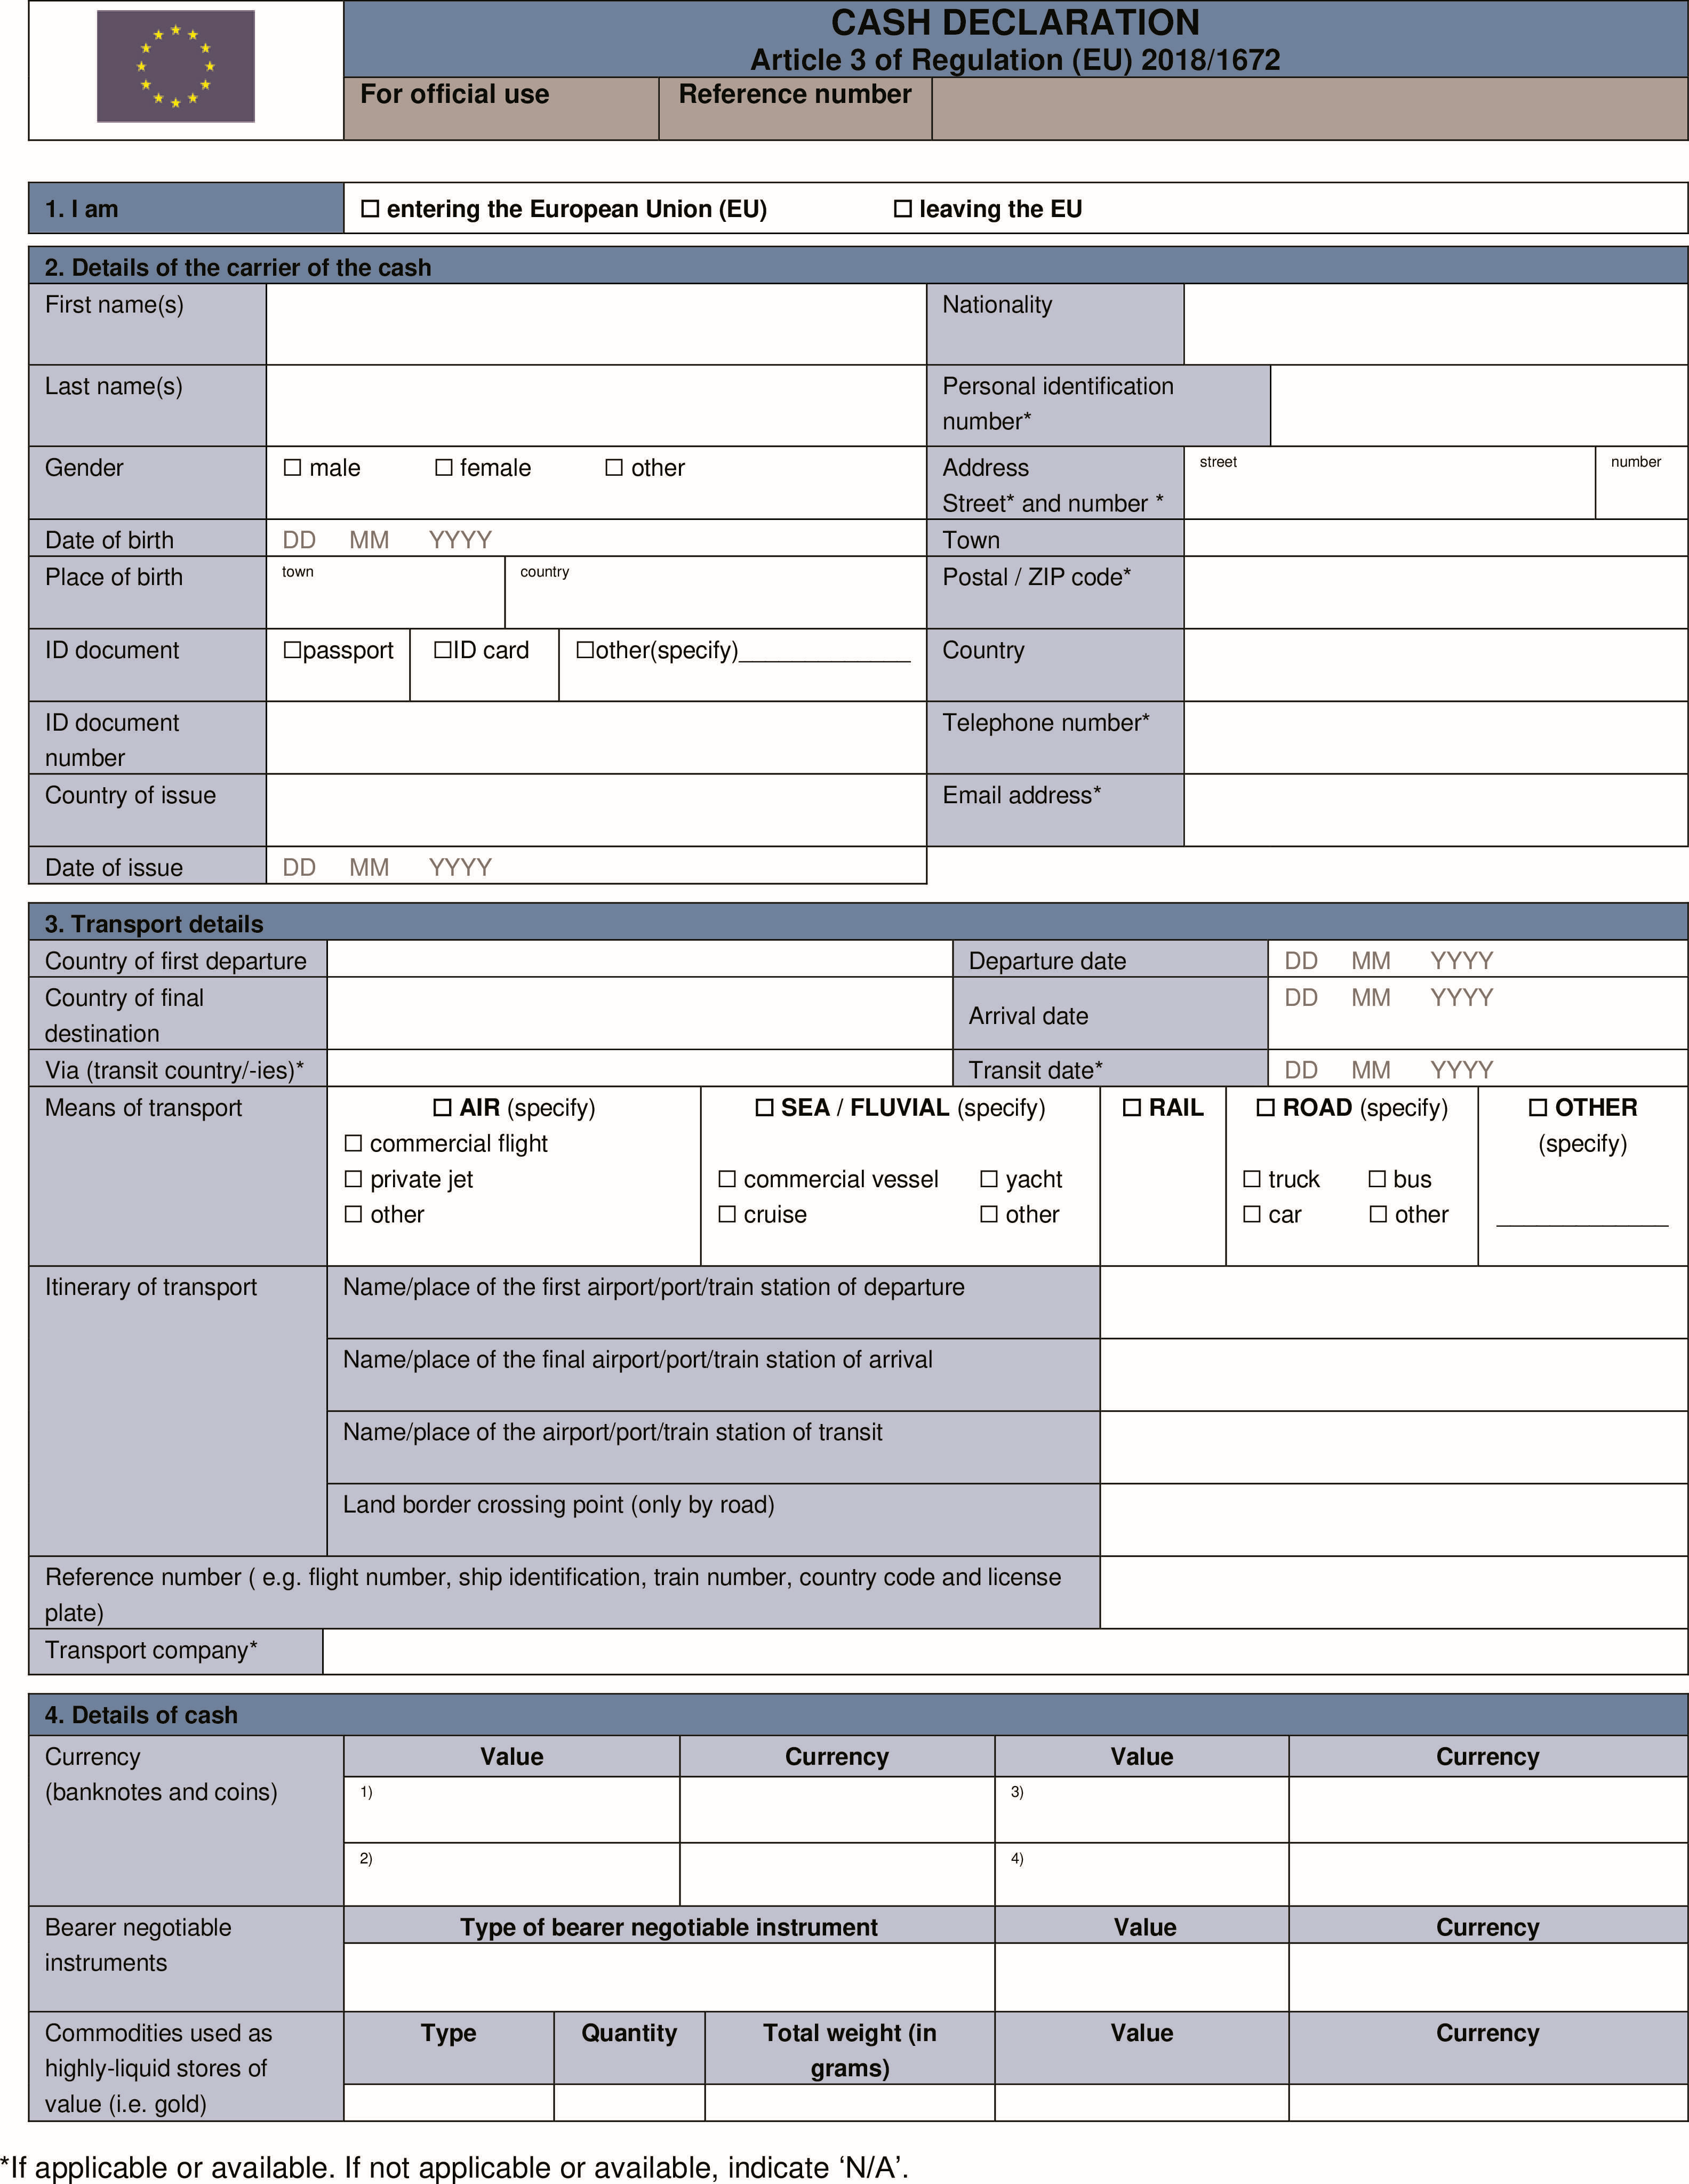
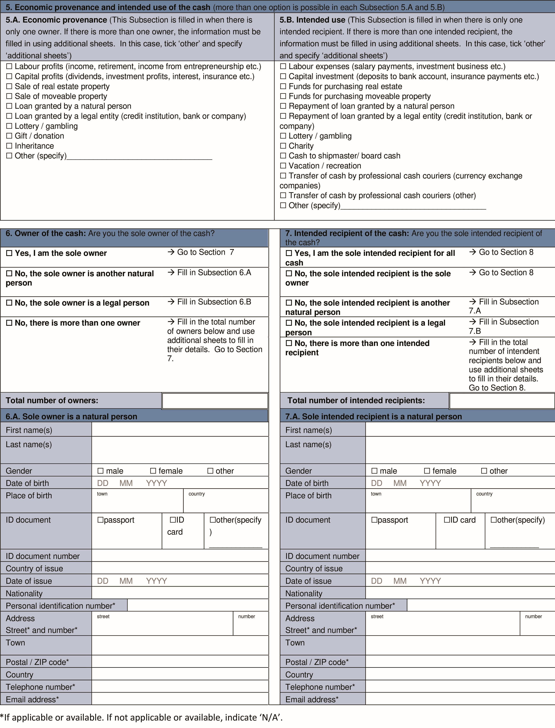

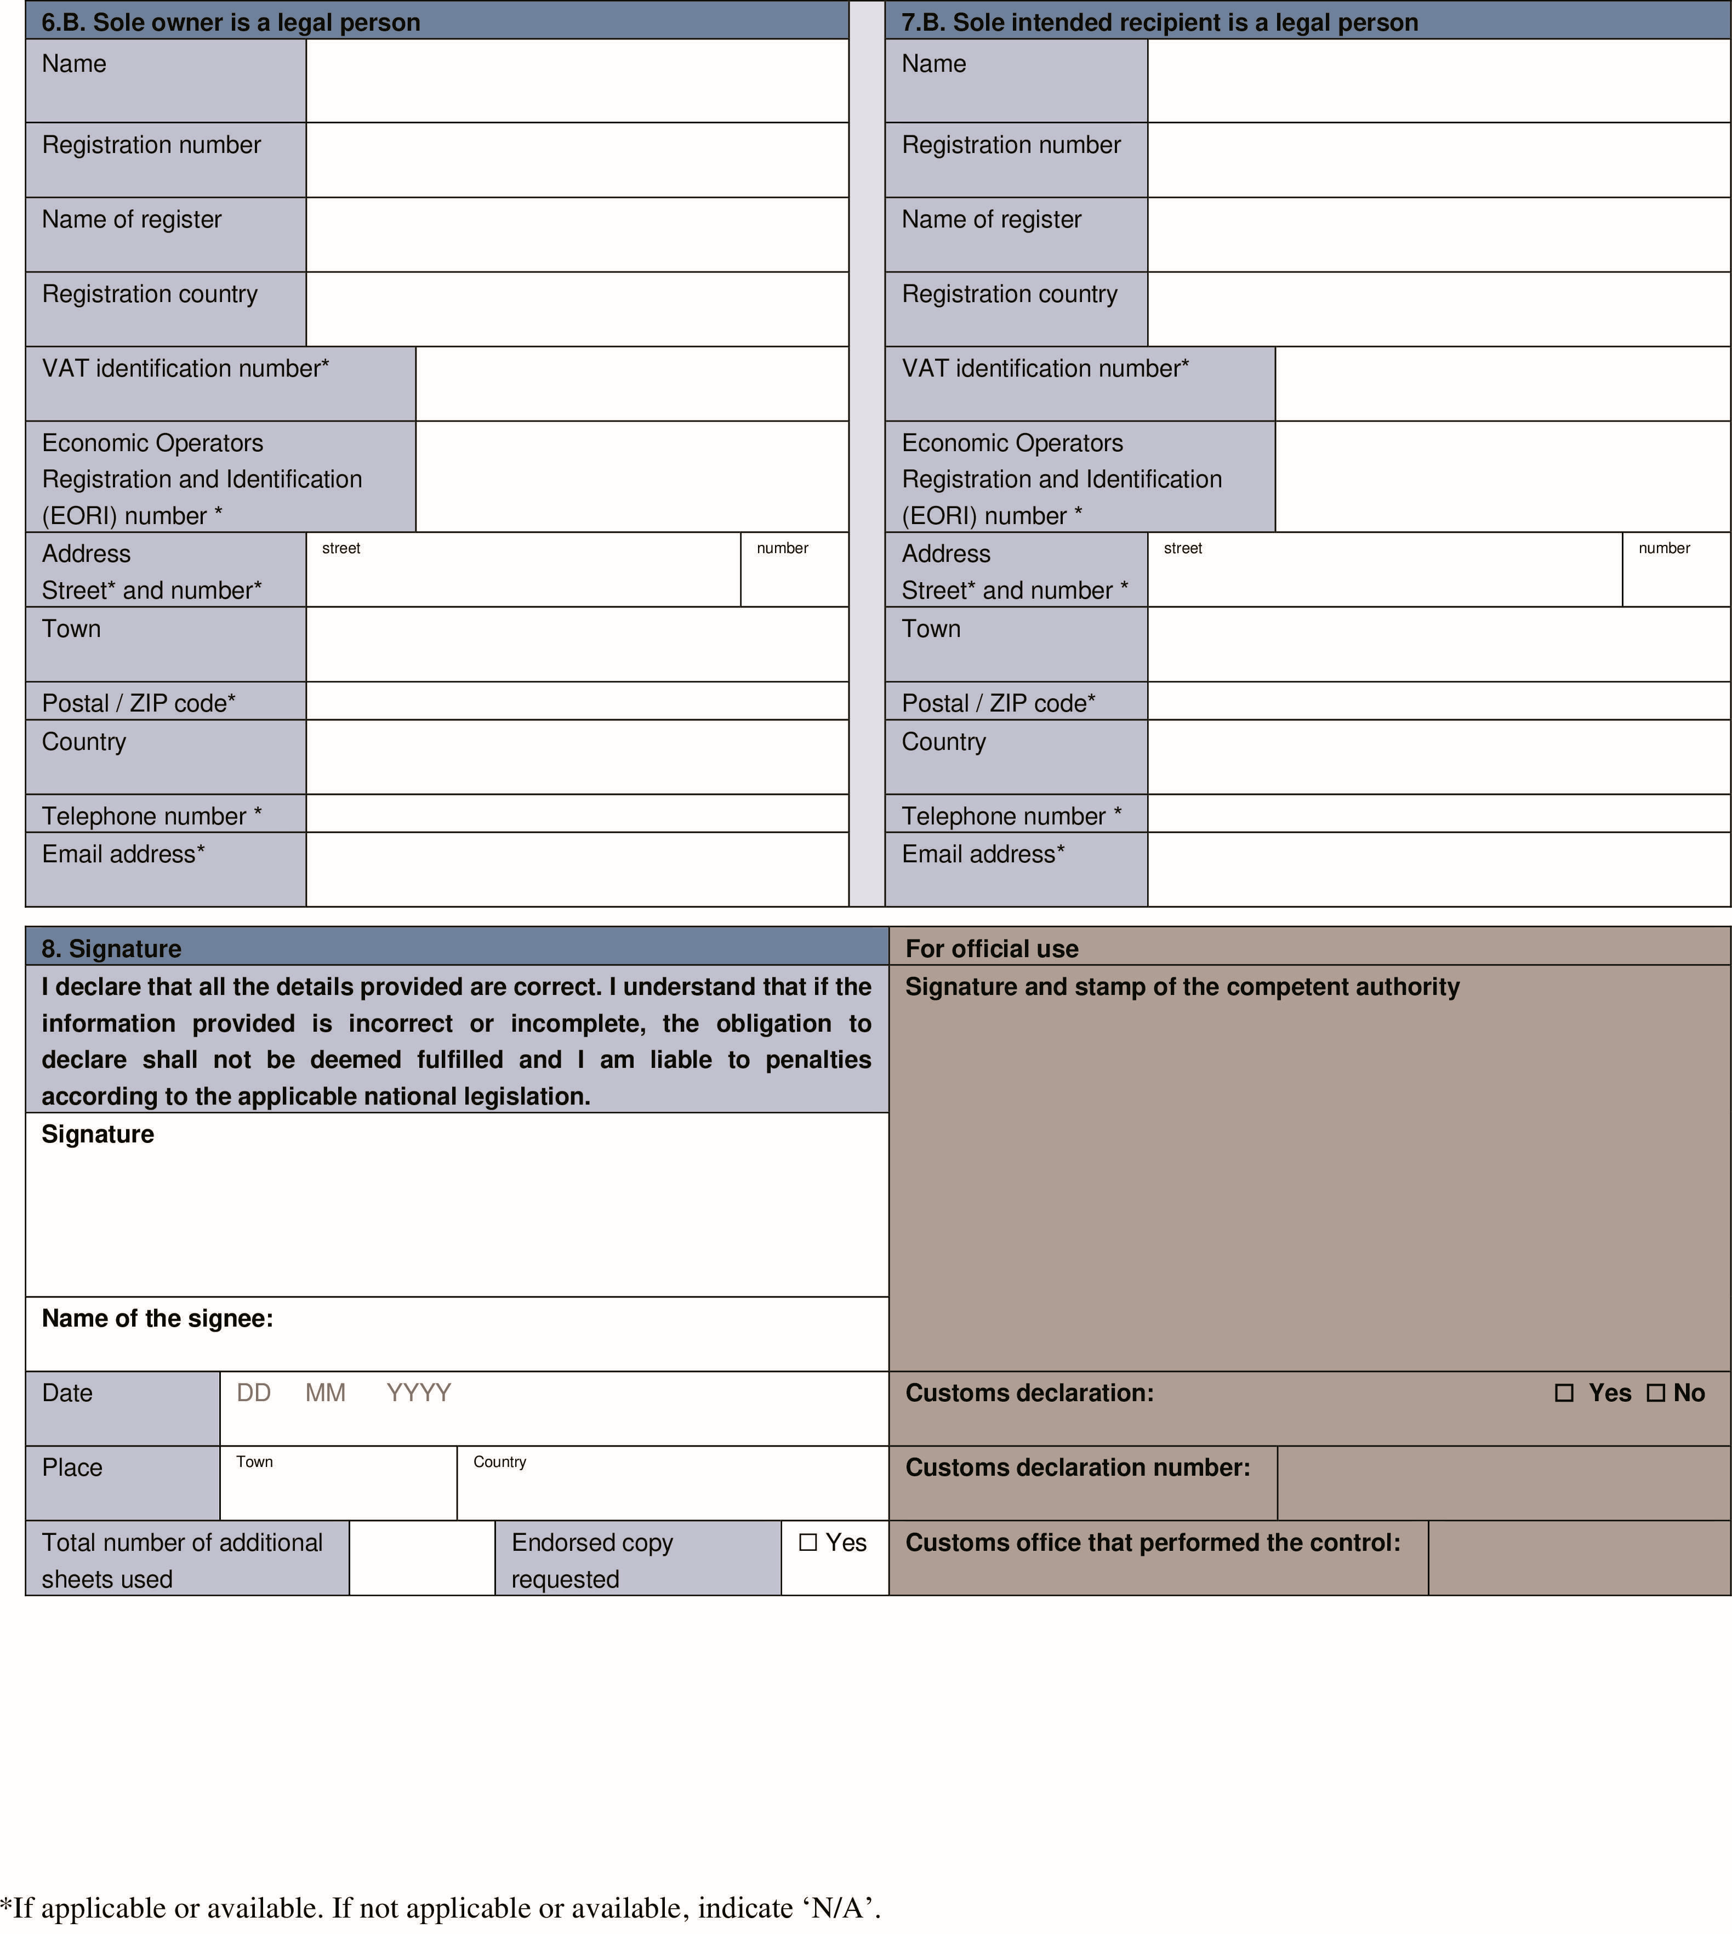

NOTES ON COMPLETION

GENERAL INFORMATION
The obligation to declare cash on entering or leaving the EU is part of the EU’s strategy to prevent money laundering and to fight terrorism financing. This declaration form must be completed when entering or leaving the EU and carrying EUR 10 000or more (or the equivalent in other currencies) in cash (Article 3 of Regulation (EU) 2018/1672 of the European Parliament and of the Council).

If incorrect or incomplete information is provided, or if the cash is not made available for control, the carrier is not considered to have met their obligation and is liable to penalties under the applicable national legislation.

Information and personal data shall be recorded and processed by the competent authorities and shall be made available to the Financial Intelligence Unit (FIU) in accordance with Article 9 of Regulation (EU) 2018/1672. In the cases referred to in Articles 10 and 11 of that Regulation, the data will also be made available to the authorities mentioned there. The competent authorities of the Member State where the declaration is submitted act as controllers of the personal data obtained and will keep personal data collected in line with Article 13 of Regulation (EU) 2018/1672, by default for 5 years. The processing of personal data takes place only for the purposes of the prevention and fight against criminal activities. For complete information, including on your rights, see attached privacy statement/ link to Member State data protection online information.

EXPLANATION OF USED TERMS IN ACCORDANCE WITH REGULATION (EU) 2018/1672

Carrier means any natural person entering or leaving the EU carrying cash on their person, in their luggage or in their means of transport.

Currency means banknotes and coins that are in circulation as a medium of exchange or that have been in circulation as a medium of exchange and can still be exchanged through financial institutions or central banks for banknotes and coins that are in circulation as a medium of exchange.

Bearer-negotiable instruments means instruments other than currency, which entitle their holders to claim a financial amount upon presentation of the instruments without having to prove their identity or entitlement to that amount. Those instruments are:

(a)traveller’s cheques; [and]

(b)cheques, promissory notes or money orders that are either in bearer form, signed but with the payee’s name omitted, endorsed without restriction, made out to a fictitious payee, or otherwise in such form that title thereto passes upon delivery.

Commodities used as highly-liquid stores of value

(a)coins with a gold content of at least 90 %; [and]

(b)bullion such as bars, nuggets or clumps with a gold content of at least 99,5 %.

- All fields in the form are mandatory fields and must be completed. Fields in the form marked with an asterisk (*) must be completed, where applicable or available.

- All parts in white must be completed in block capital letters and dark ink. Forms must not contain crossing out, overwritten words or other alterations.

- The parts marked ‘for official use’must remain blank.

- Personal identification number (i.e. personal tax, social security or similar unique personal identification number), address, postal code / ZIP code, telephone number and email address must be filled in, if applicable. If not applicable, indicate ‘N/A’instead.

- Value Added Tax (VAT) number and Economic operator registration and identification Number (EORI Number -which is a unique number, across the EU, assigned by a customs authority in a Member State to economic operators involved in customs activities) must be filled in where available. If not available indicate ‘N/A’.

- Where information is not known to the carrier, indicate ‘unknown’.
- The form must be completed in one of the official languages of the EU accepted by the competent authorities of the Member State where the declaration is made.

Section 1: Entering or leaving the EU

Tick the appropriate box to indicate if the carrier is entering or leaving the EU. A declaration on entering and on leaving, is required also if transiting through the EU.

Section 2: Details of the carrier of the cash

The carrier’s personal data must be filled in this section as they appear on their ID document.

Where the carrier of the cash is not legally capable of signing the declaration, the declaration is submitted by the carrier’s legal representative.

Section 3: Transport details

Information on the country of first departure, the country of final destination and the means of transport must be provided. Information on the transit country or countries through which the carrier transfers cash and the transport company must be specified, if applicable.

— Tick box ‘Air’if entering or leaving the EU by aircraft. The type of aircraft (commercial flight, private jet, other) must be provided. The flight number or aircraft registration number (in case of a private jet) must be provided in field ‘Reference number’.
— Tick box ‘Sea / Fluvial’if entering or leaving the EU by sea or river. The type of vessel (commercial vessel, yacht or other) must be provided. The vessel’s name must be provided in field “Reference number”and shipping line details must be provided under “Transport company”.
— Tick box ‘Road’if entering or leaving the EU by any kind of motorised road vehicle. The type of road transport (truck, car, bus, other) must be provided. The country code and licence plate of the vehicle must be provided in the field ‘Reference number’.
— Tick box ‘Rail’if entering or leaving the EU by train. The train number must be provided in the field ‘Reference number’and the train company must be provided under ’Transport company’.
— Tick box ‘Other’if none of the other transport modes is used and specify the type of transport (e.g. pedestrian traffic, bicycle).

Section 4: Details of the cash

The total amount of cash carried by the carrier must be filled in this section. ‘Cash’is defined under ‘General Information’. At least one of the options [(i) currency; (ii) bearer-negotiable instruments or (iii) commodities used as highly-liquid stores of value] must be filled in.

If there is insufficient space on the declaration form, the additional sheets must be used to provide the details of the cash. All information provided constitutes a single declaration and all additional sheets must be numbered and signed.

Section 5: Economic provenance and intended use of the cash

Subsection 5.A must always be filled in if the carrier is a sole owner or if there is only one owner to indicate the relevant economic provenance.

Subsection 5.B must always be filled in if the carrier is also the sole owner and the sole intended recipient or where there is only one recipient to indicate the intended use of the cash.

It is possible to select more than one option in each Subsection. If no option is applicable, tick box ‘other’and specify the details.

If there is more than one owner or more than one intended recipient, the relevant information about the economic provenance and intended use of the cash for the owners and/or intended recipients must be filled in on additional sheets as mentioned below. In this case, tick box ‘other’and specify ‘additional sheets’.

Section 6: Owner of the cash

One owner only

If the carrier is the sole owner of the cash, tick the appropriate box and continue to Section 7.

If the carrier is not the sole owner, specify whether the sole owner is another natural person or a legal person and tick the appropriate box. The details must be filled in Subsection 6.A (for a natural person) or Subsection 6.B (for a legal person) and continue to Section 7. If the carrier is a natural person, the personal details must be filled in as they appear on their ID document.

More than one owner

If there is more than one owner, the total number of owners must be filled in the appropriate box. For each additional owner separate additional sheets must be filled in giving their details, the amount of cash owned and its economic provenance and its intended use. If the carrier is one of the owners, an additional sheet must be filled in for them as well, with the amount of cash owned by the carrier and its economic provenance and its intended use. All information provided constitutes a single declaration and all additional sheets must be numbered and signed.

Section 7: Intended recipient of the cash

One intended recipient only

Indicate whether the carrier is the sole intended recipient of the cash. If that is the case, tick the appropriate box and continue to Section 8.

If the carrier is not the sole intended recipient, tick the appropriate box to specify if the sole intended recipient is another natural person or a legal person. The information must be filled in Subsection 7.A (for a natural person) or Subsection 7.B (for a legal person) and continue to Section 8. In case of natural person, the personal data must be filled in as they appear on their ID document.

More than one intended recipient

If there is more than one intended recipient, the total number of intended recipients must be filled in the appropriate box. For each intended recipient separate additional sheets must be filled in giving the details of each intended recipient, the amount of cash to be received and its intended use. If the carrier is one of the intended recipient an additional sheet must be filled in for them as well, including the amount of cash received by the carrier and its intended use. All information provided constitutes a single declaration and all additional sheets must be numbered and signed.

Section 8: Signature

Enter the date, place and name and sign the declaration form. Indicate the total number of additional sheets used. If none has been used, indicate zero (0). The carrier can tick the appropriate box to request an endorsed copy of the declaration.

Information clause of the Head of the National Revenue Administration for persons who fill out declaration forms or disclosure of cash is available via link published at the following address:
https://www.gov.pl/web/kas/od-3-czerwca-nowe-przepisy-unijne-ws-przewozenia-pieniedzy-przez-granice

